1-Bug Life Cycle
How to write a bug report - start at 0:00
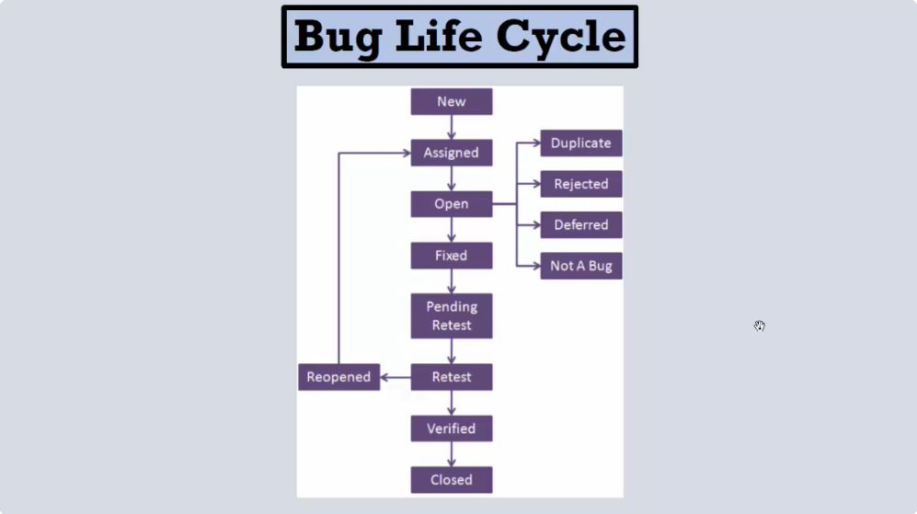

2-Bug Report
How to write a bug report - start at 1:20
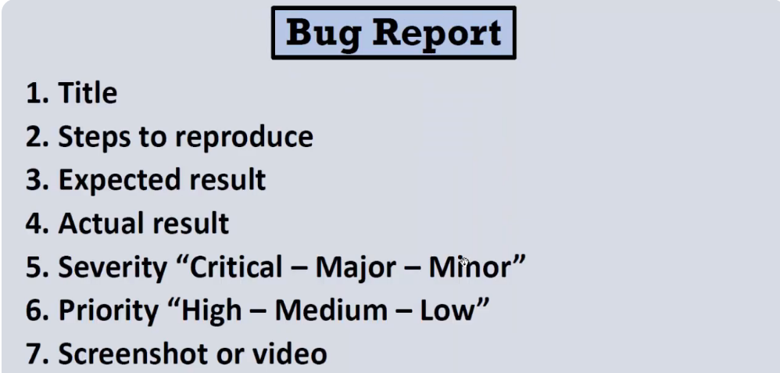
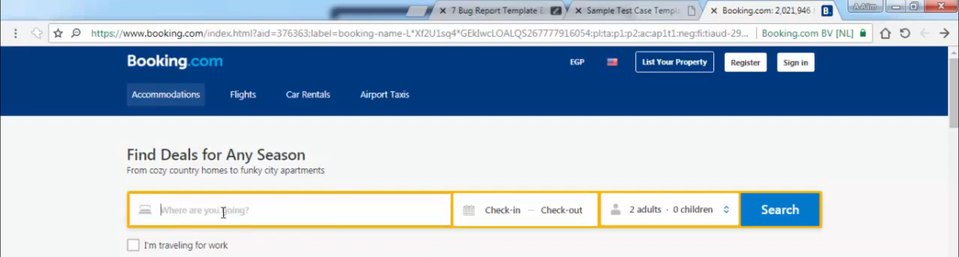

3-Bug Report Example
How to write a bug report - start at 4:11
